Sarang Bainalwar
Nagpur, India
sarangbainalwar@gmail.com

Dear Hiring Team,
I am writing to express my strong interest in the Software Developer position at eLitmus. I am currently pursuing a B.Tech in Computer Science at Shri Ramdeobaba College of Engineering and Management, Nagpur, with an expected graduation in June 2025. I specialize in full-stack web development, focusing on ReactJS, NodeJS,competetive coding in Java and API integration. Through my internships and personal projects, I have developed a passion for creating efficient, user-friendly applications that solve real-world problems.
Let me tell you a little about myself beyond the technical side. I come from a close-knit family that has always encouraged me to pursue my ambitions. My father is a retired government official, retired in 2013 and my mother is a housewife. My younger brother is pursuing BCA. Our main source of income is my father’s pension on which we are solely relied on. Being an older boy of the house, its on my shoulders to take responsibility of the house and educate my younger brother.
Outside of academics, I have always sought opportunities to push my limits. Whether it’s participating in hackathons or collaborating on research projects like synthetic image generation using GANs. My work as a web developer intern at CodeClause gave me practical exposure to implementing and testing responsive designs while also improving my debugging and feature development skills.
In terms of recognitions, I co-authored a research paper on Generative Adversarial Networks, demonstrating my ability to apply academic concepts to impactful projects. Additionally, I hold certifications in Microsoft Azure and Generative AI, further enhancing my skills in cloud computing and AI technologies.
I am particularly drawn to eLitmus because of the freedom it offers to innovate and create history. The opportunity to work closely with leaders on projects that can transform industries is incredibly motivating. I am excited about the prospect of working across the entire development lifecycle—from ideation to deployment—while being encouraged to work on side projects that can leverage eLitmus' resources to grow into something significant.
I am confident that my blend of technical expertise, creative problem-solving skills, and passion for making an impact make me a strong fit for this role. I look forward to the opportunity to contribute to eLitmus and be a part of its mission to create something truly revolutionary.
Thank you for considering my application. I am eager to discuss how I can contribute to your team.
Best regards,
Sarang Bainalwar
[LinkedIn](https://www.linkedin.com/in/sarang-bainalwar-748a1822a/) | [GitHub](https://github.com/sarangbainalwar) | [Portfolio](https://sarangbainalwar.vercel.app/)

Nagpur, India 440024
9168336955
sarangbainalwar@gmail.com
LinkedIn | GitHub | Portfolio
Sarang Bainalwar
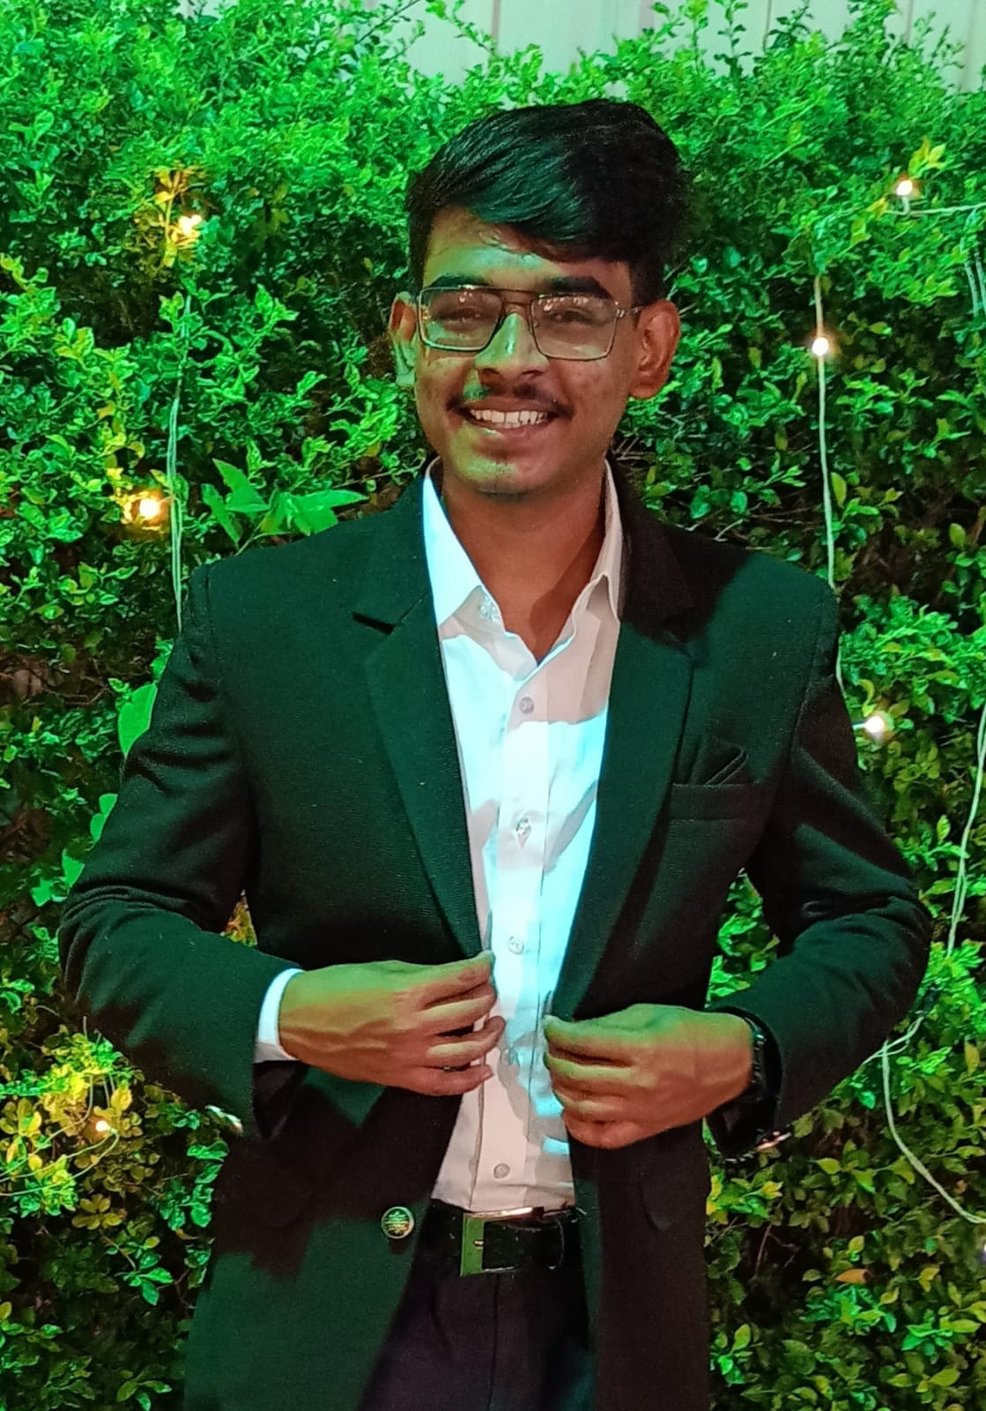

Professional Summary
Experienced Web Developer specializing in full-stack development with a focus on ReactJS and API integration. Proficient in HTML5, CSS3, JavaScript, and backend technologies such as NodeJS and ExpressJS. Expertise in database management with MongoDB and deploying scalable applications on AWS. Adept at creating responsive, user-centric web solutions that align with client objectives and deliver exceptional user experiences.
Technical Skills
- Front-end: HTML5, CSS3, JavaScript, ReactJS, TailwindCSS, jQuery
- Back-end: NodeJS, ExpressJS, RESTful APIs, MongoDB, AWS,RDBMS,PL-SQL
- APIs: RESTful APIs, React Chat Engine API; Programming: Java
- Tools and Platforms: Git, GitHub, Vercel, Netlify, Postman, Insomnia
- API Integration and Testing, Software testing
Soft Skills:
- Team player
- Adaptive
- Effective communicator
- Amicable
- Persistent
Work History
Web Developer Intern
CodeClause, Nagpur, Maharashtra
November 2023 - December 2023
- Developed and maintained dynamic frontend components utilizing ReactJS and TailwindCSS.
- Improved project code quality through rigorous debugging and comprehensive testing.
Education
B.Tech in Computer Science
Shri Ramdeobaba College of Engineering and Management, Nagpur, Maharashtra
Expected in June 2025
Projects
Online Password Keeper: passxonline.netlify.app
- Developed a secure online password keeper utilizing HTML, CSS, and JavaScript.
- Implemented local storage API for secure data management and user authentication.
React Chat App: sbchatapp.vercel.app/
- Created a real-time chat application using ReactJS and React Chat Engine.
- Integrated Chat Engine API for seamless real-time messaging, providing a smooth user experience.
Personal Portfolio: sarangbainalwar.vercel.app
- A personal portfolio showcasing projects and skills. Built with ReactJS and styled using TailwindCSS.
- Deployed on Vercel for seamless access.
GAN-based Image Generation Project
- Developed a project using Convolutional Neural Networks (CNN) and Generative Adversarial Networks (GANs) for synthetic image generation.
- Implemented GAN architecture to create high-quality synthetic images.
- Co-authored a research paper on the project, highlighting the methodology and outcomes.
Certifications
- Microsoft Azure Foundations: Basics of cloud computing services and Microsoft Azure platform.
- Introduction to Blockchain Foundation: Fundamental concepts of blockchain technology and its applications.
- Generative AI: Introduction to generative AI techniques and their use in real-world applications.

